Recrystallization of Epsom salt

Introduction

The main objective of this experiment was to observe recrystallization of Epsom Salt. A salt is a naturally occurring compound that is formed as a result of a reaction between base and acid. A salt occurs as a white cubic crystals which are odorless, soluble in water and has strong salty taste. Salts are hygroscopic meaning they have an ability to attracts and contain water molecules from the surrounding.
Salt is a naturally-occurring mineral and a chemical compound with amazing properties. These properties enable salt to be used in everything from preserving food to making it taste better. Epsom salt is primarily used for health reasons. People use it to make soft water for relaxing, treat constipation, and sore muscles.

Recrystallization of salt occurs when impure salt is dissolved in a hot liquid until the solution gets saturated and then the liquid is allowed to cool. The result of this process is formation of pure crystals

Epsom Salt Crystals

Requirements
- Epsom salt
- Food coloring
- Beaker, cup, or small bowl

Procedure

In the beaker, stirred 1/2 cup of Epsom salts with 1/2 cup of very hot tap water for at least one minute. This created a saturated solution, meaning no more salt can dissolve in the water. (Some undissolved crystals will be at the bottom of the glass.) Then added a couple drops of food coloring for crystals to be colored. I then placed the beaker in the refrigerator. Finally I checked on it in a few hours to see a beaker full of Epsom salt crystals then poured off the remaining solution to examine them.

Observation and Explanations

During recrystallization process, a solute is mixed with a solvent until the resulting solution becomes saturated after which the solution I left to cool and in the event pure crystals are formed. Ideally when you perform a recrystallization processes, it equals to purifying a salt, and impurities remain in the solution while the pure crystals grow. The crystals are then removed from the solution by filtration

A successful recrystallization relies on choice of solvent, the salt must be soluble in the solvent when the solvent is hot and insole when solvent is cold. The cooling processes on the other hand determines the quality and size of the crystals. When there is slow cooling, large crystals and much purer are formed but when cooling is faster it results in small crystals.

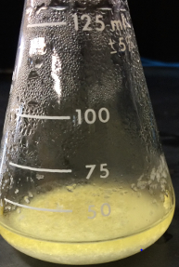

The recrystallization product of Epsom salt in a solution of water before being crystalizing and being filtered

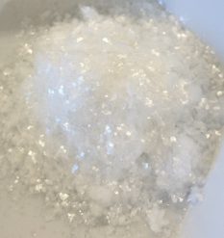

The product after recrystallization and filtration.

